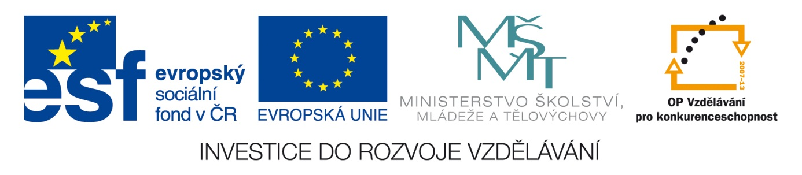

SECOND HYDAP WORKSHOP
Airborne remote sensing in soil science
&

FIRST DISCUSSION PANEL
Interdisciplinary approaches in soil assessment

at

Global Change Research Centre AS CR, v.v.i., Czech Republic
June 25-28, 2013

Dear partners,

let us invite you to the second HyDaP Workshop and the first discussion panel.
The workshop will be held at Global Change Research Centre, Brno, Bělidla 4a, (see map).

Within the workshop, you are primarily invited to the lectures and practical training "Soil Spectroscopy" delivered by Prof. Eyal Ben Dor from Tel-Aviv Univ. and
discusion panel coordinated by Prof. Jan Frouz, Institute of Soil Biology, Biology Centre ASCR, v. v. i.

Please note that the workshop and panel will be held in English.

If interested, please register via Doodle and confirm your attendance on email glocova.p@czechglobe.cz together with your accommodation requirements, including dates and room type (single/double-bedded)
until 28 May 2013.

The expenses on accommodation and refreshment during the workshop will be covered by the organizer of the workshop (CVGZ).

We look forward to you and to all those who are interested in the remote sensing topic.

Program:

June 25, 2013 (13.00-17.30)
Discussion panel – 1st part coordinated by Prof. Jan Frouz, Institute of Soil Biology, Biology Centre ASCR, v. v. i.

Introduction to soil science
Processes of soil formation
Soil composition, structure, chemistry
Soil organic matter, carbon sequestration, soil fertility
Czech and World soil classification systems

June 26, 2013 (9.00-12.00)
Workshop – 1st part, Prof. Eyal Ben Dor., Tel-Aviv Univ.
The nature and properties of soils
Interaction with environment, three phase composition, classification and exposure
Soil Spectroscopy 1: Definition, evaluation and development: past present and future
Soil Spectroscopy 2: Chromophores (physical and chemical), Hapke’s theory and Hunt libraries, refractive and reflation, absorption, transmittance and reflectance

June 26, 2013 (13.30-17.30)
Soil spectroscopy 3: All domains - problems and solutions (BRDF, Moisture, Near Infrared)
Exercise
Measurement with three ASDs with and with our protocol and normalization procedure

June 27, 2013 (9.00-12.00)
Workshop – 2nd part, Prof. Eyal Ben Dor., Tel-Aviv Univ.
Analysis: Definition, evaluation and current status in soil and other disciplines.
Soil analysis and measurements – problems and protocol s (lab, field and air/space borne)
Soil analysis NIRS + all options (pre-processing, analytical methods, statistical measures)
Soil Spectral Libraries and worldwide expert working group: The LUCAS and SWSG libraries.

June 27, 2013 (13.30-17.30)
Exercise
Analysis of soil contaminated with TPH (unscrabmler, other methods)
Working with the set from 2 using the PARCUDA over the CLOUD - comparison

June 28, 2013 (9.00-14.00)
Discussion panel – 2nd part, coordinated by Prof. Jan Frouz, Institute of Soil Biology, Biology Centre ASCR, v. v. i. and Dept. of Remote Sensing CVGZ v.v.i.

Interdisciplinary tasks between remote sensing and soil/vegetation sciences
Project overlaps between HyDaP partners (thermal regime, crop production)
Potential publications and projects

