CA15226: Climate-Smart Forestry in Mountain Regions

WG4: DEVELOPMENT OF INNOVATIVE SCHEMES OF PAYMENT FOR ECOSYSTEM SERVICES (PES)
1st WG4 meeting: Incentives for sustainable provision of forest ecosystem services in European mountains: practice of existing PES schemes.

October 4th – 6th 2017
VELKÉ KARLOVICE
The aim of the meeting is to progress in review of existing theories and practices for forest ecosystem services PES schemes in mountain regions (Task 4.1). In particular we plan to analyzes collected examples of the Payment for Ecosystem Services (PES) and jointly develop meta-analyses criteria to drown lesson learn for European mountain forest.
Preliminary program of the meeting:
October 4, 2017, Wednesday

17:00 Welcome drink and dinner followed by discussion on European PES (invited speaker under consideration)
October 5, 2017, Thursday
9:00 - 17:00 WG4 meeting:
- results of review process undertaken in task 4.1.
- criteria for meta-analysis comparative study
October 6, 2017, Friday
9:00 - 11:00 Summing up and departure
The international conference “Quo vadis agriculture, forestry and society under the global change?” is held in the same place in October 2nd – 4th, 2017 for more information see: http://czechglobe.cz/en/quo_vaditis_en/ Participants of the workshop are encouraged to consider participation at the conference That includes also excursion to ICOS site in Bily Kriz.
Venue of the WG meeting:
Hotel HORAL, Velké Karlovice, Leskove 583, Czech Republic
http://www.horal-hotel.cz/hotel-horalen.html
Wellness hotel in the mountain area in a beautiful countryside, it is equipped with its own spa. The meeting, accommodation (and the conference) is all situated at one place, so there is no need to move from one place to another.
Accommodation:
The double and single rooms are booked directly in the Hotel HORAL. It is necessary that YOU confirm your attendance and RESERVATIONS no later than April 13.^{th} !!! The reason for this requirement is that the hotel is fully booked for subsequent events. Replying to this message stating name, duration and room preference: Viera Bastakova <bastakova.viera@gmail.com> we have guaranteed prices for the “CLIMO Workshop”.
Prices:
Single room – standard 95 Euro/night/person
Double room – standard (room shared by 2 people) 70 Euro/night/person
There are only 5 standard rooms remaining (for 5 the fastest registered)!
Single room – residence E 110 Euro/night/person
Double room – residence E (room shared by 2 people) 80 Euro/night/person

COST Action chair set up limit for WG meeting to 80 Euro/night/person. However, the food is much cheaper in the Czech Republic than elsewhere, so you should save additional money in meal reimbursements (regular lunch is less than 10 Euro, big dinner is for 15 Euro). We might also encourage you to share rooms, if possible.
You can cancel your reservation without any penalty until the end of July (or 44 days before the event), but for this moment – to be able to guarantee your room – you need RESERVE THE ROOM AS SOON AS POSSIBLE. Thank you!
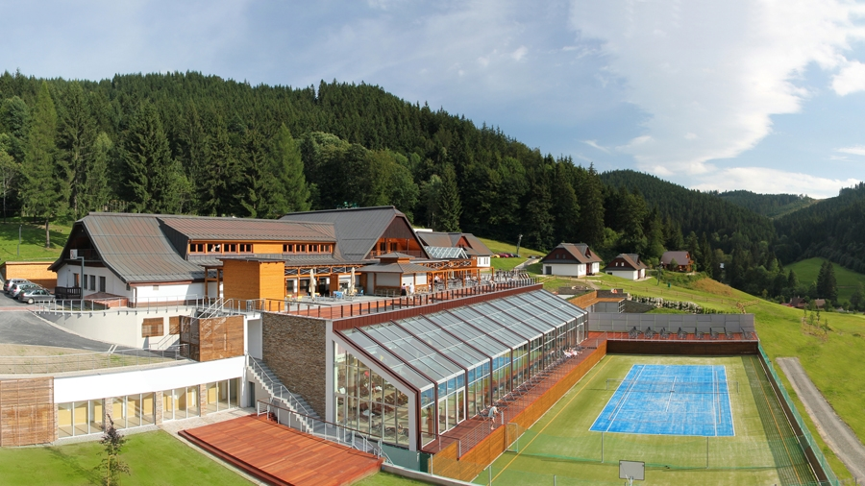
Transport
The venue is in the countryside but well connected.
From more distant destinations, you might fly to Prague (Czech Republic), Vienna (Austria) or Bratislava (Slovakia).
There, you need to switch for the train to get to Vsetín or/and Velké Karlovice:
- From Prague, there is an Express train going directly to Vsetín every 2 hours (9:22, 11:22, 13:22, 15:22, 17:22). The journey takes about 3,5 hours. In Vsetín, you need to switch for the local train to Velké Karlovice (it is the final station, the train from Vsetín goes every hour). The hotel is about 8 km from the Velké Karlovice train station, so we will pick you up there or we also consider to arrange the shuttle from Vsetín.
- From Bratislava, you need to get the train to Púchov and there switch to get to Vsetín (so there is one change). The train from Bratislava goes every 2 hours (9:55, 11:55, 13:55, 15:55) and the journey takes 3 hours to get to Vsetín. In Vsetín, you need to switch for the local train to Velké Karlovice (it is the final station, the train from Vsetín goes every hour). The hotel is about 8 km from the Velké Karlovice train station, so we will pick you up there or we also consider shuttle from Vsetín.
- From Vienna, you need to take Express train from the airport – it leaves from the airport every half an hour at .03 and 0.33 minutes past the hour. It takes about 15 minutes to Vienna Hbf (main station). From the main station there are two possible ways - by Euro City Train (14:10) or Express train (18:10) to Hranice na Moravě, it takes approximately 3 hours. From Hranice na Moravě you need to take an Express train to Vsetín and then the local train/bus from Vsetín to Velké Karlovice. It takes 4 hours in total and is thus SHORTEST option. The hotel is about 8 km from the Velké Karlovice train station, so we will pick you up there or we also consider shuttle from Vsetín.

Price limit for transport for WG meetings has been set as well. It is maximum 400 Euro/person. The return tickets of trains from Prague and/or Vienna/Bratislava should be less than 30 Euros.

